**Connecting a Project's Parts With a Network Diagram**

Network Diagrams are often confused with PERT charts. This article shows through images Network Diagrams and describes how they work.

**What are Network Diagrams?**

A Network Diagram is a visual representation of a project’s schedule. Well known complements to network diagrams include the [PERT](http://www.brighthub.com/office/project-management/articles/2871.aspx) and [Gantt](http://www.brighthub.com/office/project-management/articles/6550.aspx) charts. A network diagram in project management is useful for planning and tracking the project from beginning to finish. It represents a project’s critical path as well as the scope for the project.

A good network diagram will be a clear and concise graphic representation of a project.

**How do Network Diagrams work?**

[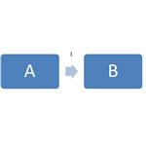](http://images.brighthub.com/C6/6/C666C5513853756D0A194A5C91E5485C5ECAA9AB_large.jpg)

There are two types of network diagrams: The Arrow Diagram and the Precedence diagram. The arrow diagram depicts nodes for events and arrows for activities. The precedence diagram depicts activities in the order they occur. If you work in IT you will most likely use the arrow diagram, depicted to the left.

‘A’ and ‘B’ each represents an event node. These event nodes refer to an instant when an activity is started or completed. An event node occurs only when all activities entering the node have been completed. The arrow represents the activity that takes place during the event. For

[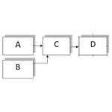](http://images.brighthub.com/87/9/87914F092CF237754E5BFD633FDBA641D35E4CC4_large.jpg)

example, if a task in a project were “research competition’s ad campaign,” then the event nodes would designate the start and finish of this activity whereas the arrow would designate the activity itself.

Using the arrow and node method, you can depict project dependencies. In the diagram to the right, you see that Event C depends upon activities from Events A and B to be completed, and Event D depends upon Event C’s activities to be completed.

Dotted lines with arrows represent “dummy arrows.” Rather than depict a dependency between two items, these arrows depict a logical relationship. Dummy arrows have no duration. They do not depict an activity. Instead, they transfer logic from one event node to another.

Once the project is mapped out, you can write a key for the visual representation, listing the duration of events and activities. The network diagram will provide you and your project team with a full visual representation of your [project](http://www.brighthub.com/office/project-management/articles/39024.aspx).

**When are Network Diagrams Used?**

Network diagrams are used whenever project management occurs.

Because these project management tools are so useful, they can help project management teams to visualize the planning they have put time and effort into.

The diagram gives a quick-glance view of the project. It also demonstrates who is responsible for which tasks.

# Constructing a Project Network Diagram

So, you’ve got the project activities list ready. In what sequence, will you implement the project? Construct a Precedence Diagram, a.k.a Project Network Diagram, and you’ll have a visual representation of the project activity flow. You can then also identify the critical path diagram.

## Introduction to a Precedence Diagram or a Project Network Diagram

In this article, we’ll illustrate how to construct a [Precedence Diagram](http://www.brighthub.com/office/project-management/articles/49580.aspx) (Project Network Diagram). The steps are:

1. Specify predecessors and successors, given a list of project activities.
2. Arrange the project activities in order of execution.

## Specify Predecessors and Successors Given a List of Project Activities

This is the first step to creating a Precedence Diagram (Project Network Diagram). In this step, the project activity dependencies are identified. The Precedence Diagram (Project Network Diagram) needs to clearly illustrate these dependencies.

While creating a list of project activities, you need to ask yourself the following questions:

* What project activities happen before the activity being examined?
* What project activities can happen at the same time with this activity?
* What project activities happen after this activity?

For example, suppose you are constructing a shed and the following activity list has been defined:

Purchase Wood; Hire Workers; Dig Foundation; Lay Foundation; Harden Foundation Cement; Purchase Plot; Select Design; Assemble Shed; Purchase Paint

Suppose, you are examining the Purchase Wood activity. Ask yourself the three questions list above.

* **What project activities happen before the activities being examined?** Some activities that may occur before the “Purchase Wood” activity include: Purchase Plot and Select Design
* **What project activities can happen at the same time with this activity?** Some activities that may occur at the same time as “Purchase Wood” activity include: Hire Workers and Purchase Paint
* **What project activities happen after this activity?** Some activities that may occur after the “Purchase Wood” activity include: Assemble Shed.

From the answers, we have determined the predecessors and successors of the Purchase Wood activity. Similarly, you can examine each project activity and develop relationships between each one (see the image below - click for a larger view). You will then have table of project activities, which also contain information about predecessors and successors.

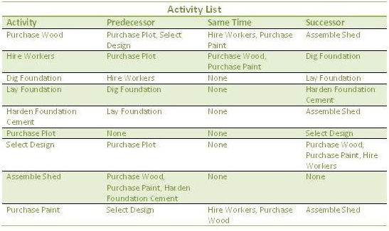

The activity list would contain the entire scope. Generally, the scope of work that needs to be

completed is broken into more manageable phases (releases and iterations). Each phase will have its own Precedence Diagram (Project Network Diagram). Prioritizing scope that provides maximum value is important. [Read the Scope Prioritization Using Risk and Value article for more information](http://www.brighthub.com/office/project-management/articles/31635.aspx).

## Arrange Project Activities in Order of Execution to create a Precedence Diagram

After creating the table, you can then proceed to constructing the Precedence Diagram (Project Network Diagram). An example precedence diagram is shown in the image. Refer to the table, while creating the project network diagram. The visual representation helps you to identify missing activities. In this example, “Cut Wood” may be a missing activity, that’ll depend on “Hire Workers.” Can you spot any other missing activities?

Usually, there are multiple paths of completion for any project, hence the Precedence Diagram may vary. For example, in the example shown in the image, we could make Purchase Paint dependent on Purchasing Wood. This would alter the precedence diagram and consequently the project schedule.

**Important**: You need to also be aware of Leads and Lags between activities. Read the [**Examples of Leads and Lags**](http://www.brighthub.com/office/project-management/articles/51758.aspx) article.

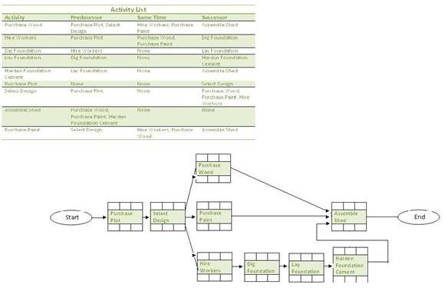

## Tools Used to Create a Precedence Diagram

In a complex project, you will probably not create the Precedence Diagram (Project Network Diagram) manually as we have done in this example. You will most likely use software, such as PS8, to create the Precedence Diagram. However, even in the software, you will need to manually enter the project activities list and the dependencies between them. The software you use, such as **PS8 or** [**Microsoft Project**](http://www.brighthub.com/office/project-management/reviews/2516.aspx), will consist of a gamut of other useful features, like **automatically creating the critical path and a** [**Gantt chart**](http://www.brighthub.com/office/project-management/articles/6550.aspx).

Another approach to creating a Project Network Diagram used often in teams involves **writing project activities on stickies and then sticking them on a whiteboard**. You will then manually draw the relationship between the project activities. The **advantages of using this approach** are:

* The Project Network Diagram can be created with inputs from several people at the same time.
* High visibility thanks to the whiteboards.
* Quick modification because stickies can be placed anywhere and arrows can be erased easily.

After creating a Network Diagram, you will need to use the Critical Path Method (CPM) to determine:

* the critical path diagram (project activities that can cause delay),
* t[he Float for each activity](http://www.brighthub.com/office/project-management/articles/49583.aspx),
* the optimal project activity flow, and
* create a schedule.

For more information, see the [**Using the Critical Path Method**](http://www.brighthub.com/office/project-management/articles/49584.aspx)article.